**NGK Report Preparation**

**About the report:**

NGK report is created to compare the success rate of payment done across different kiosks. The comparison is based on the type of kiosks. Currently we take success rate of IBM, BLS, NGK Series-0 & NGK Series-1 kiosk.

**Pre-requisites:**

* Install mongo db in your local machine
* Java version: jdk 1.7.0
* Tomcat server: apache-tomcat-7.0
* Configure cassandrabatchici & ChinnPinn in your local eclipse workspace.
* Configure mongo-db in your local machine.

**Note before starting the application:**

* Make sure mongo-db is started before launching the application.

**Pre-requisites for report preparation:**

* ReportController.java -> kioskId_Properties (Configure the ‘kioskids.properties’ file path to your local workspace path).
* batch-context.xml
  + Configure the file path for ‘technical’ logs [Check for - <bean id="multiLineReaderDelegate”].
  + “org.springframework.scheduling.quartz.SchedulerFactoryBean” – To configure the time for triggering the batch (Normally configure 2 minutes in advance, before you start the batch)
* batch.properties
  + kiosk.log.inputpath – Input file path for ‘Soap/Technical’ logs.
  + kiosk.log.outputfile – Output file path for results.
* Configure tomcat server in workspace and add ‘chipin-web’ project and start the server.

**Pre-requisites for logs download:**

* Need to download soap_messaging & webkiosk_technical logs.
* Unzip all the .gz files of soap_messaging & webkiosk_technical in separate folder.

**Report Generation:**

***Note*: Steps can be executed in the given order in-order to save time for making the report**

1. **For NGK (Series 0 & 1) Kiosks:**
   1. Configure batch-context.xml file for ‘technical’ log path and also the time for cron-job execution.
   2. Ensure the time is future time (ahead of 2 or 3 minutes) so that job starts sooner.
   3. Execute ‘**BatchTrigger.java**’ as Java application.
   4. Ensure batch gets started sooner and once completed.
      1. Hit -> <http://localhost:8087/chinpin-web/dashboard.jsp>
      2. 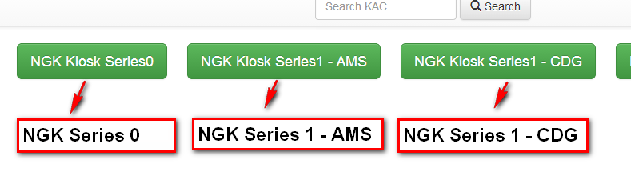
      3. Click on NGK Kiosk series 0 and NGK Kiosk series 1 on different browser tabs to retrieve results faster.
      4.  
      5. No.Of EMD Failure values:
         1. Unzip " psm_emd_20141009_OPCO0371.csv.gz” file and change the file extension to .log
         2. Open the file in excel, Select Delimiter as “Semicolon” and enable filter.
         3. Select “SUBCHANNEL – TPEAMS & TPECDGF2 only.
         4. Select “STATUS - Other than ‘Issued’”.
         5. The count of line left-out is the count for EMD failure.
2. **For BLS Kiosk & IBM kiosk:**
   1. Configure batch.properties file for the below parameters - (Mostly the change will be the folder path for each and every day logs)
      1. kiosk.log.BLS.inputpath
      2. kiosk.log.BLS.outputfile
      3. kiosk.log.IBM.inputpath
      4. kiosk.log.IBM.outputfile
   2. Execute ‘**FlatFileItemReaderJobConfigurationTest.java**’ as Junit test file.
   3. Output - technical_bls.txt & soap_ibm.txt files.
      1. **For BLS kiosk: technical_bls.txt**
      2. Total Technical Chip&PinPayment BLS= No. Of lines in technical_bls.txt file
      3. Payment Technical Successful BLS = No. Of lines with “EMV ResponseCode : 0000”.
      4. **For IBM kiosk: soap_ibm.txt**
      5. Total Technical Chip&PinPayment IBM AMS = No. Of SellProducts request
      6. Payment Technical Successful IBM AMS = No. of SellProducts response with “<paymentStatusName>SOLD</paymentStatusName>”

***Additional features added:***

* **Automatic log download via batch process**
  1. Integrate LS-Scheduler project to your workspace.
  2. fancyLogDownload.properties
     + Configure the download path for the key ‘downloadLocation’ to your local path
     + Configure log download date for the key ‘downloadDate’ (the date present in the file name)
  3. applicationContext.xml
     + Configure ‘fancyLogProps’ path for fancyLogDownload.properties file path.
     + Configure cron job execution time – “logAnalyzerTrigger”*.*
  4. Execute FancyLogSchedulerMain.java as java application.
  5. Currently Technical and SOAP logs will be downloaded for our reporting tool.
  6. We can use it for other logs download as well and our log download for CK will not have any problem from now.